**Report “Lab 6”**

**Anton Tserakhau**

# OLTP – Load External References – Normalization of Data

## Task 01 – Install and expand load of external references T_Languages

I have unfolded needed scheme objects for load external reference T_Languages. Result of work:

SELECT *

FROM all_objects

WHERE owner = 'U_DW_REFERENCES' AND object_type = 'TABLE';

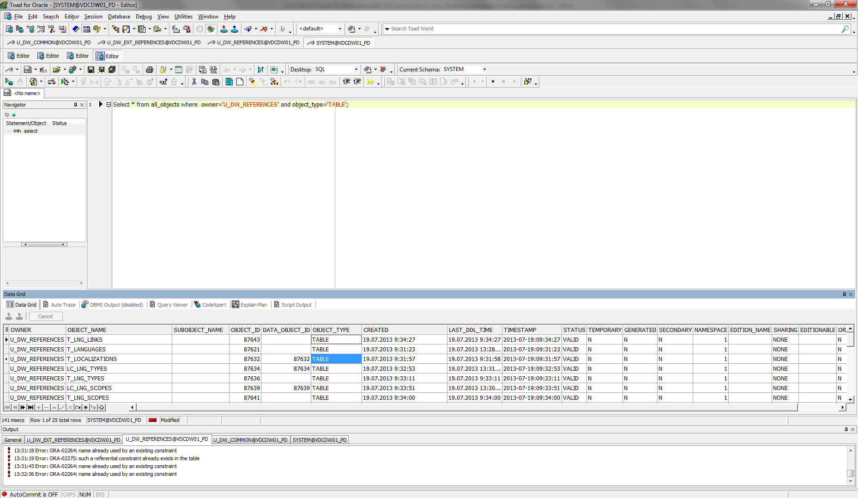

SELECT * FROM T_LOCALIZATIONS;

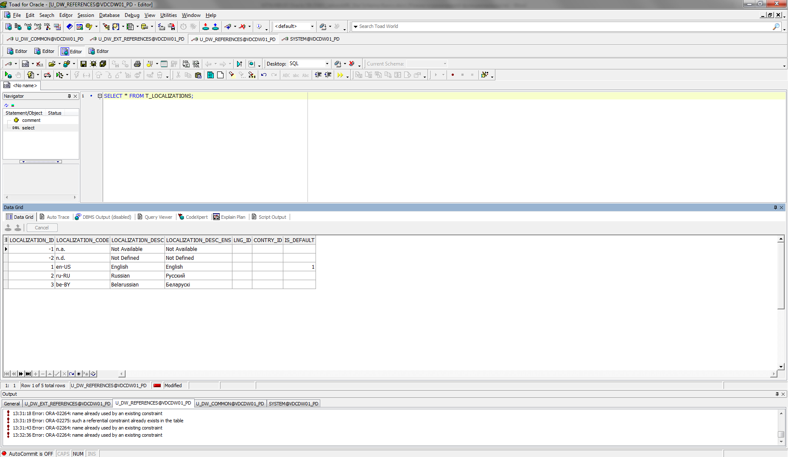

SELECT * FROM CU_LANGUAGES;

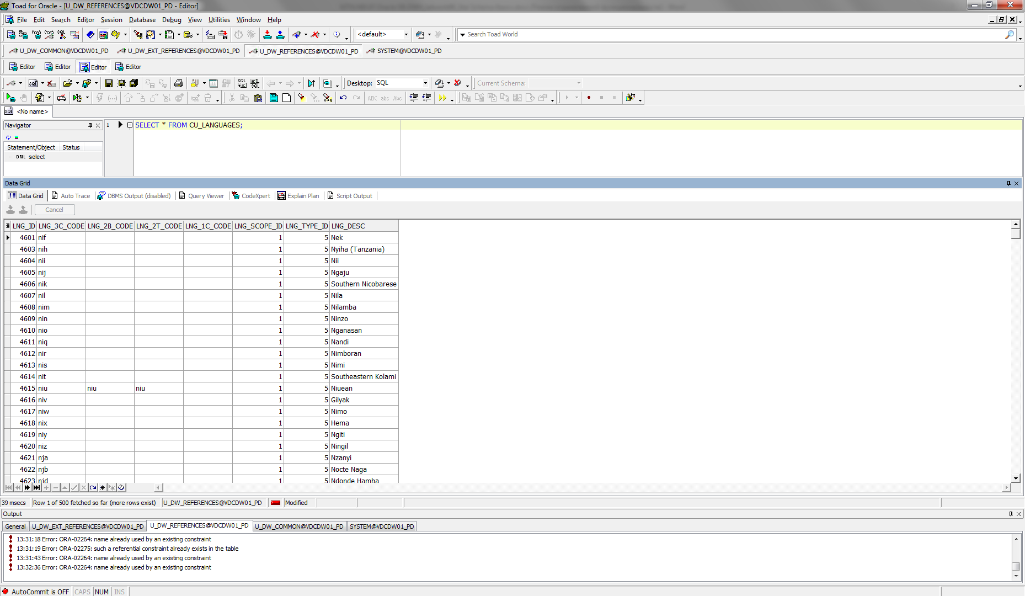

SELECT * FROM W_LNG_LINKS;

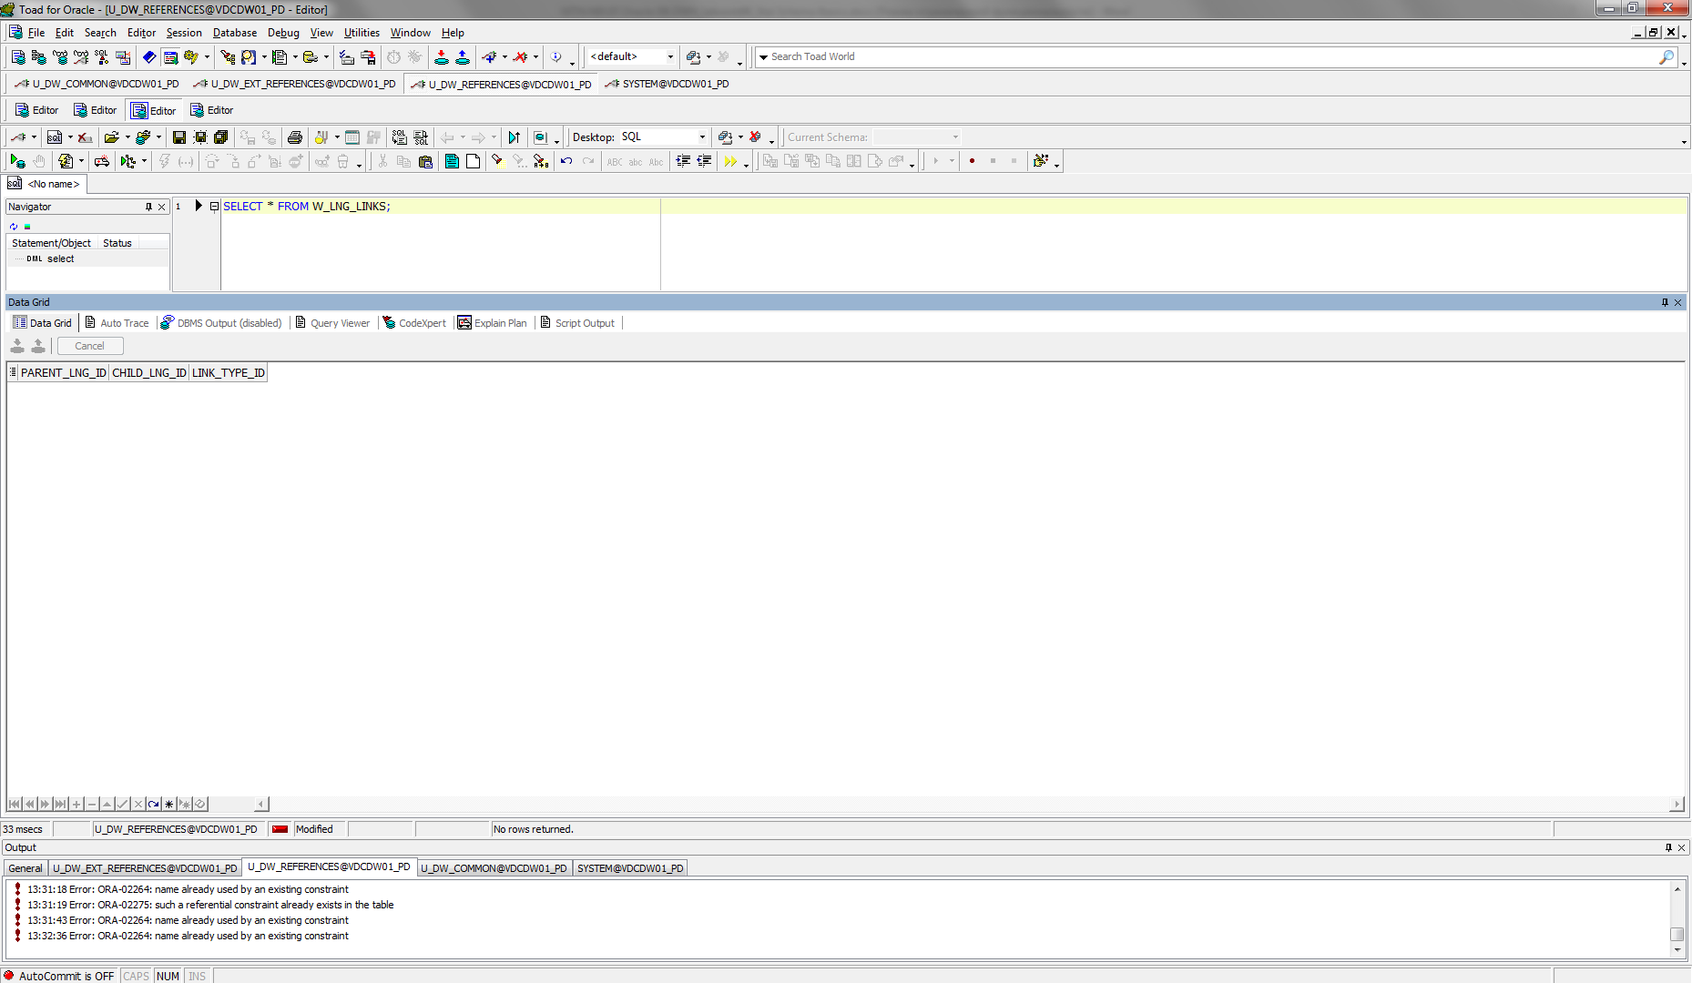

SELECT * FROM CU_LNG_SCOPES;

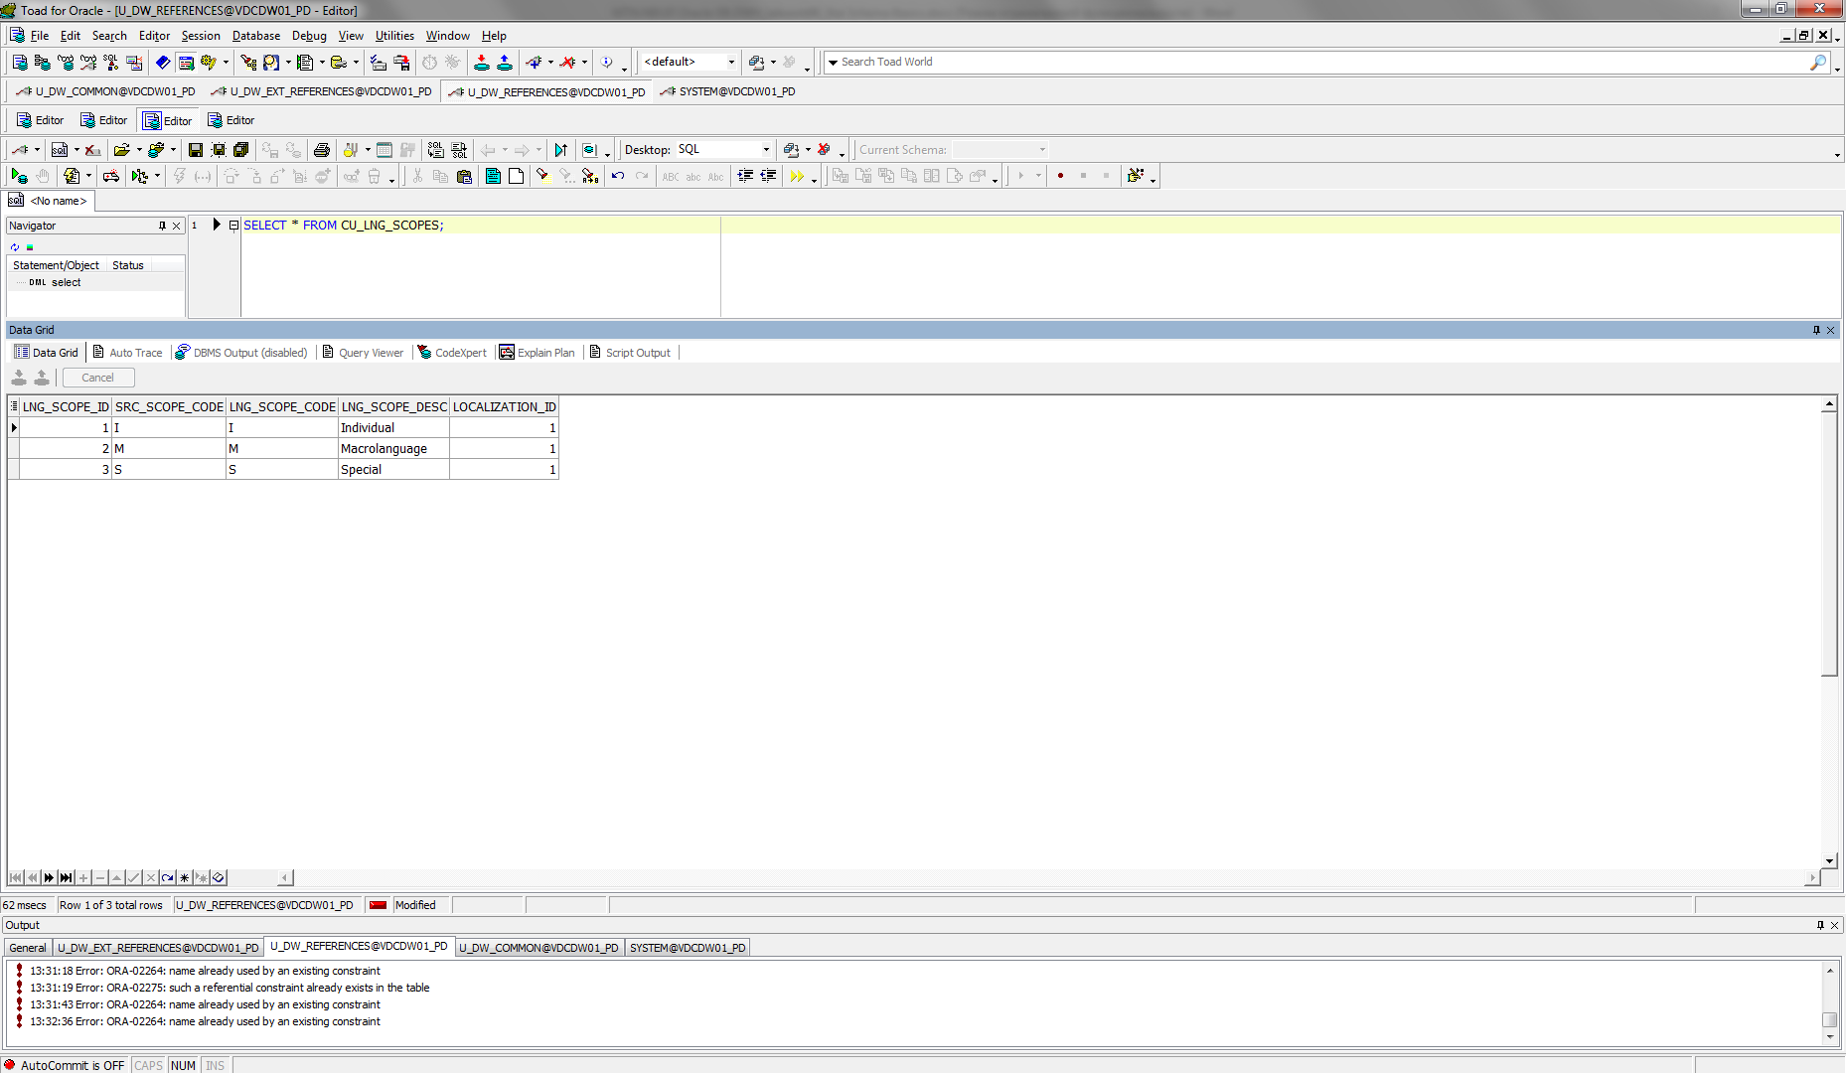

SELECT * FROM CU_LNG_TYPES;

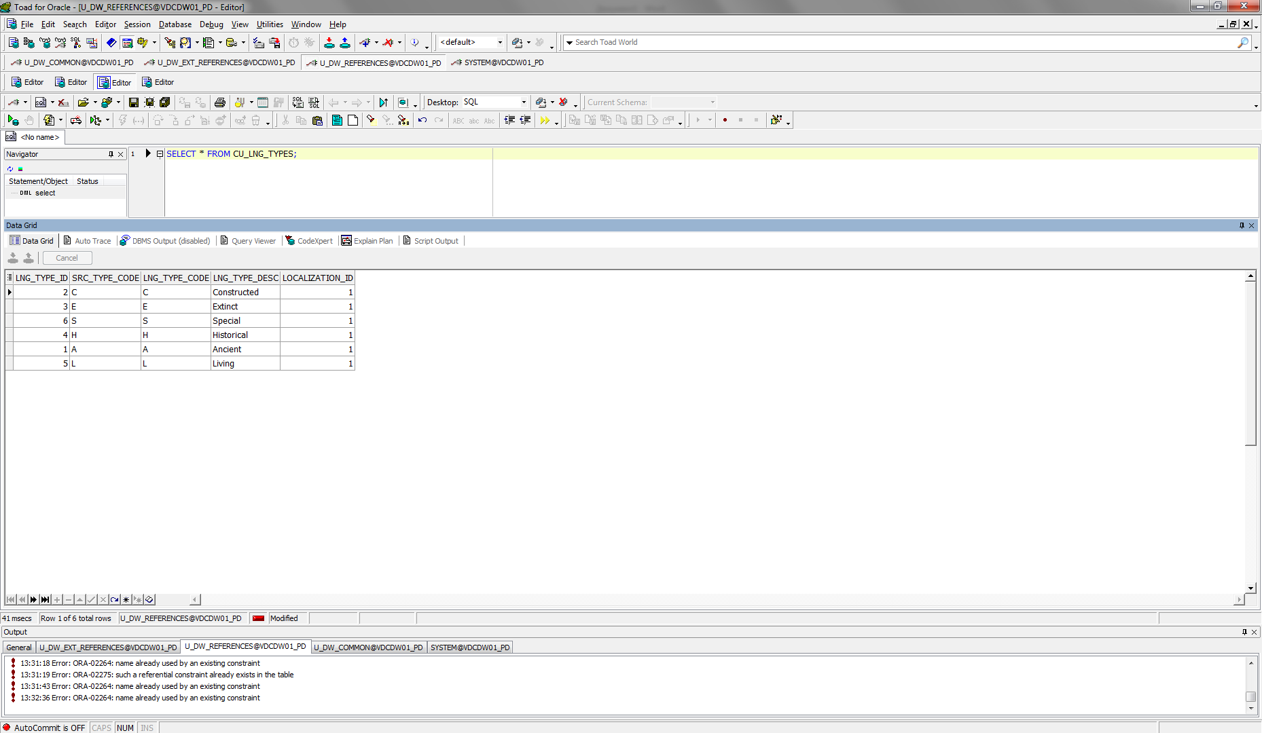

The diagram of T_Languages:

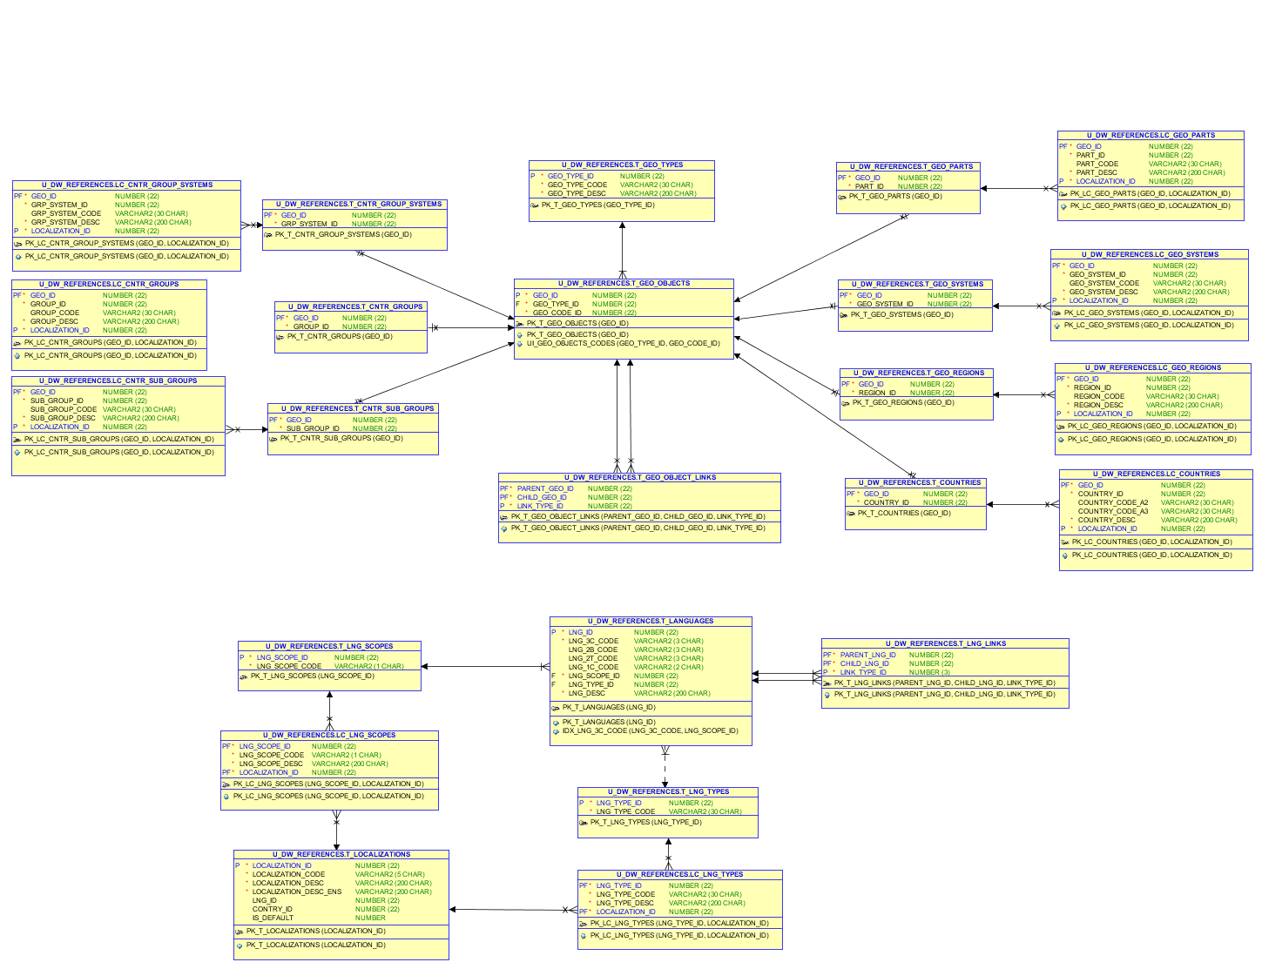

Diagram of loading external References:



## Task 02 – Create load process for External references T_Countries

I have unfolded needed scheme objects for load external reference T_Countries. Result of work:

SELECT *

FROM all_objects

WHERE owner = 'U_DW_REFERENCES' AND object_type = 'TABLE';

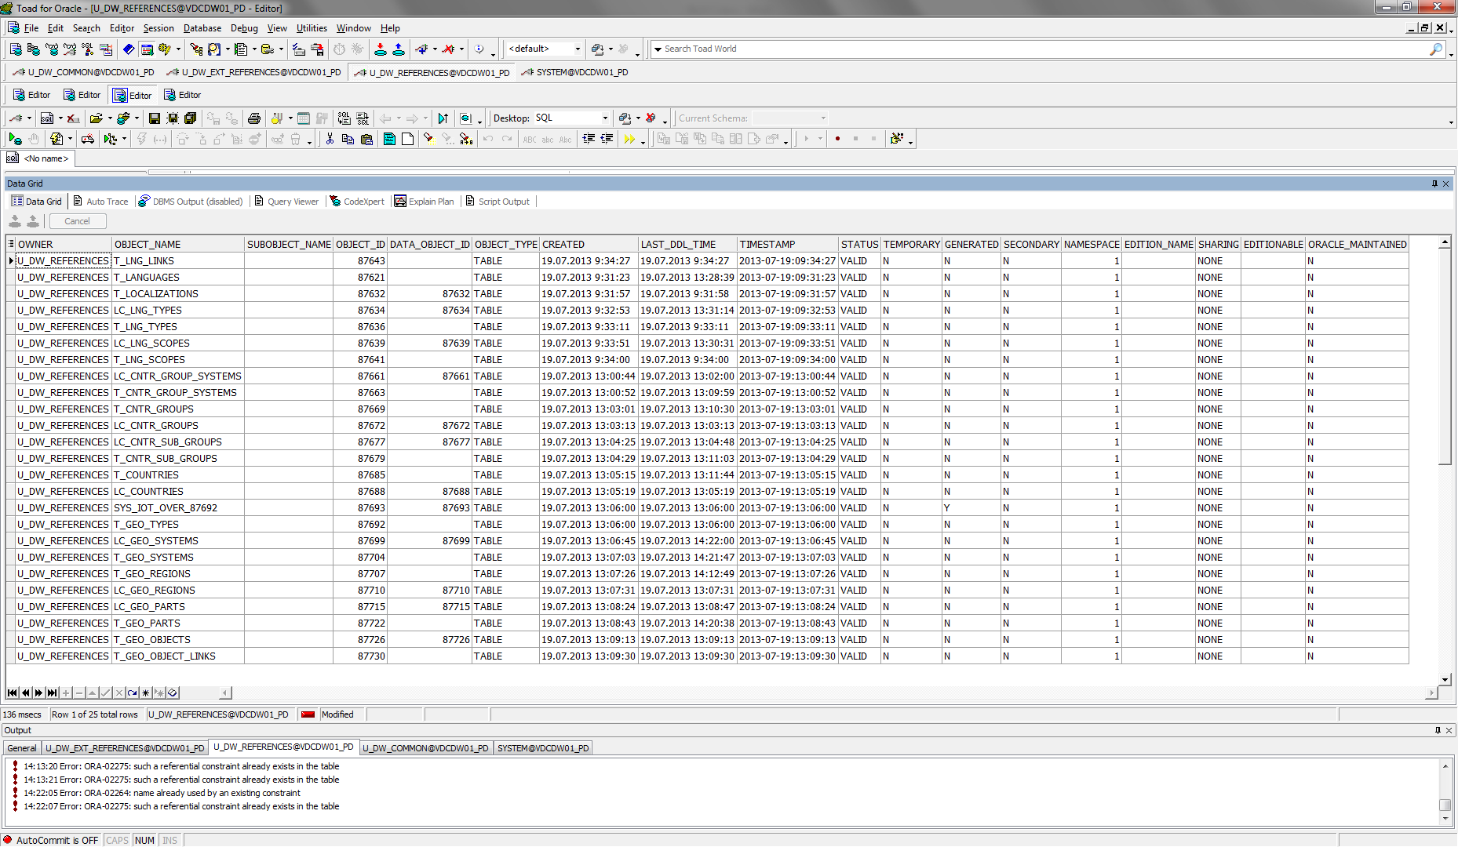

SELECT *

FROM all_objects

WHERE owner = 'U_DW_REFERENCES' AND object_type = 'VIEW';

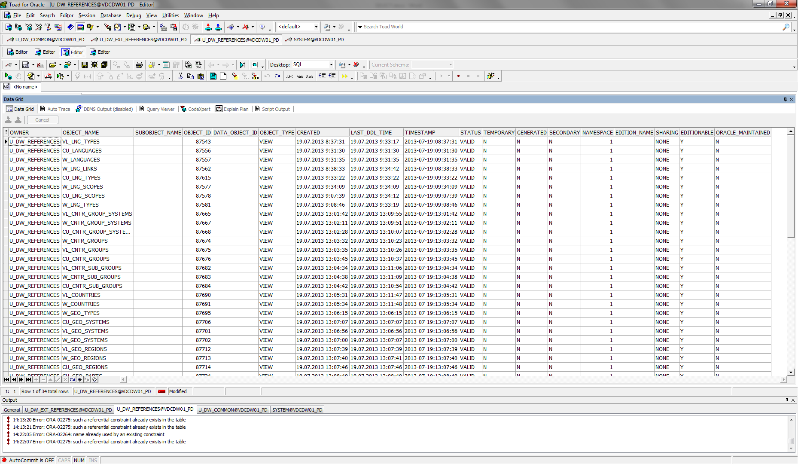

SELECT * FROM T_GEO_OBJECTS;

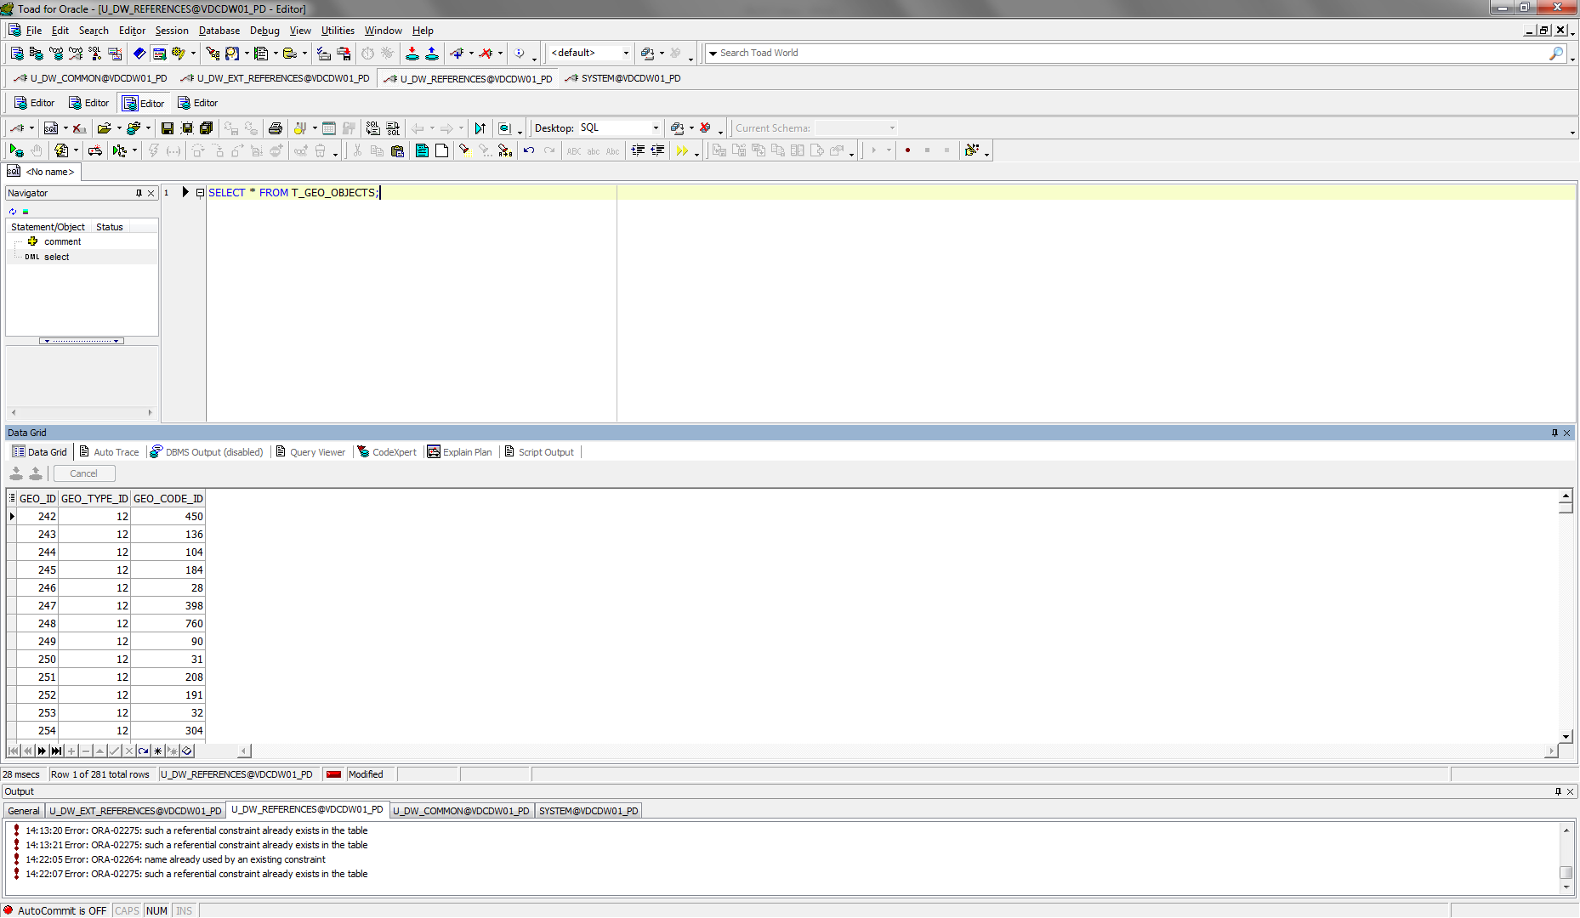

SELECT * FROM T_GEO_REGIONS;

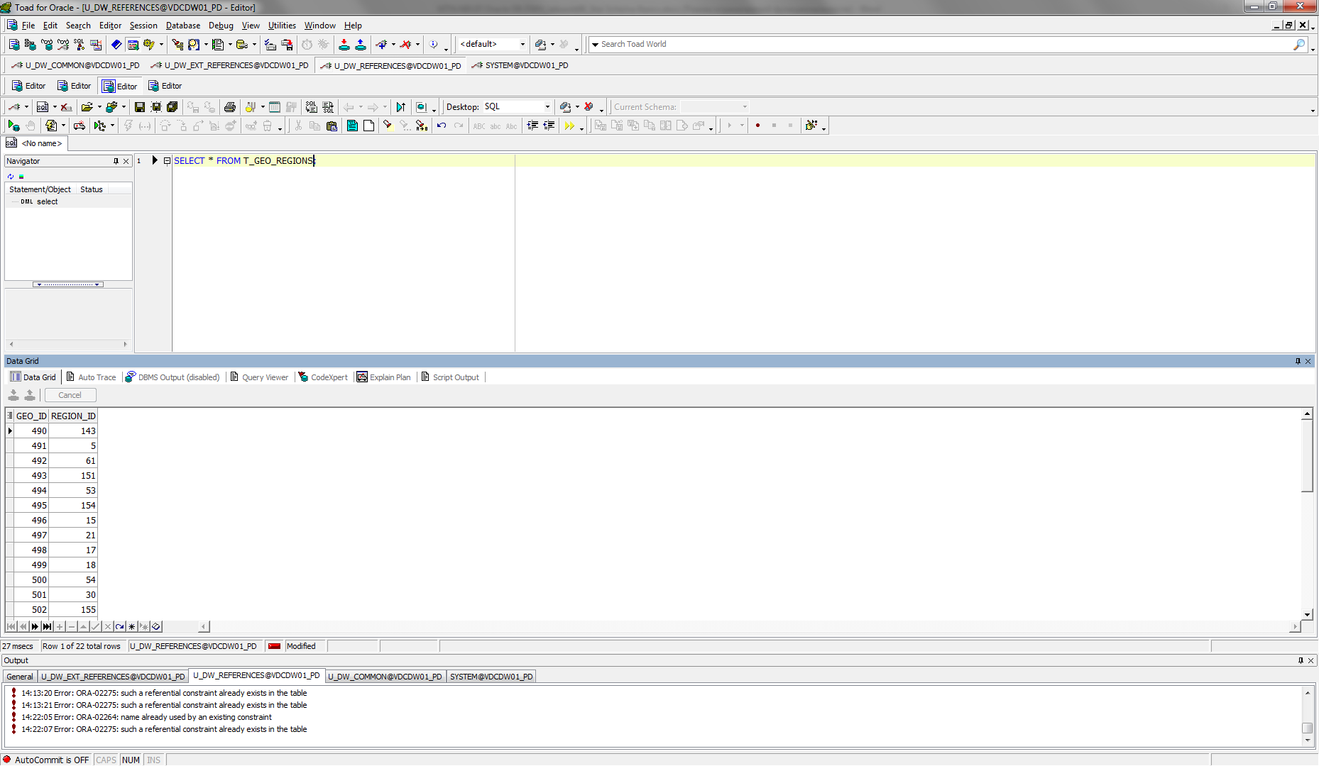

SELECT * FROM LC_GEO_REGIONS;

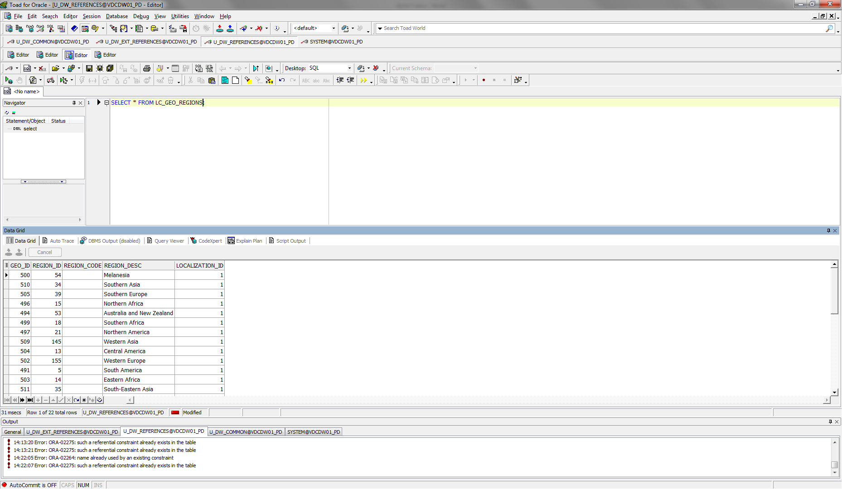

The diagram of T_Countries:

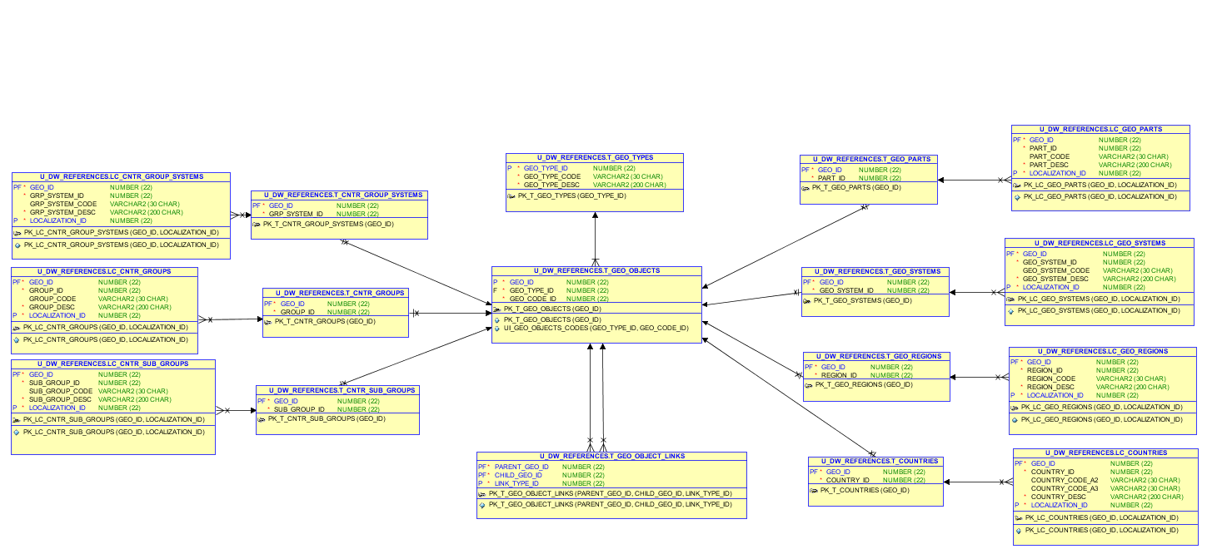

Diagram of loading external References:

